**FULL STACK DEVELOPMENT WITH MERN**

***MERN STACK BY MONGODB***

***PROJECT:***

**HOUSE RENTAL APPLICATION USING MERN**

**Team Members:**

KARTHIGAI KANNAN K (311521104024)

CHARAN M (311521104008)

ISAAC SAMUEL J (311521104018)

PRADEEP KUMAR G (311521104032)

**I INTRODUCTION**

**Project Title: HOUSE RENT APPLICATION**

**Team Members:**

Karthigai Kannan K – ***Team Lead***

Charan M- Member

Isaac Samuel J- Member

Pradeep Kumar G- Member

**II PROJECT OVERVIEW**

**TECHNOLOGY STACK**

* **Frontend:** React.js
* **Backend:** Node.js with Express
* **Database:** MongoDB
* **Authentication:** JWT (JSON Web Tokens) or similar

                     The goal of this project is to develop a web-based House Rent Application that allows users to search, list, and manage rental properties. The application will enable landlords to post property listings, and prospective tenants to search, view details, and inquire about properties. The MERN stack (MongoDB, Express.js, React, Node.js) will be used to build this application.

**PURPOSE**

                        The purpose of the House Rent Application is to create a digital platform that connects property owners and potential tenants. The platform simplifies the process of renting houses by providing a secure and user-friendly interface for searching, listing, and managing rental properties.

**KEY FEATURES**

1. **User Authentication:** Sign up, login, and logout features for users (tenants and property owners).

* Role-based access control to distinguish between tenants and property owners.

1. **Property Listings:**

* Property owners can add new property listings, including details like rent amount, property location, photos, and amenities.
* Tenants can browse and filter listings based on location, price, property type, and other criteria.

1. **Search and Filter:**

* A search and filter option for tenants to find listings based on specific criteria (e.g., address, Ad type (rent/sale), Property type(residential/commercial/plots)).

**4. Detailed Property Page:**

* A dedicated page for each property with all relevant details, photos, a description, and owners contact information.
* An option for tenants to save or bookmark properties for later.

1. **Booking or Viewing Requests**

* Tenants can send requests to view the property or book it.
* Property owners can manage these requests and respond to tenants.

**6. Admin Dashboard**

* A dashboard for admins to oversee all activity on the platform, including user management, property listings, and resolving disputes.

**III . ARCHITECTURE**

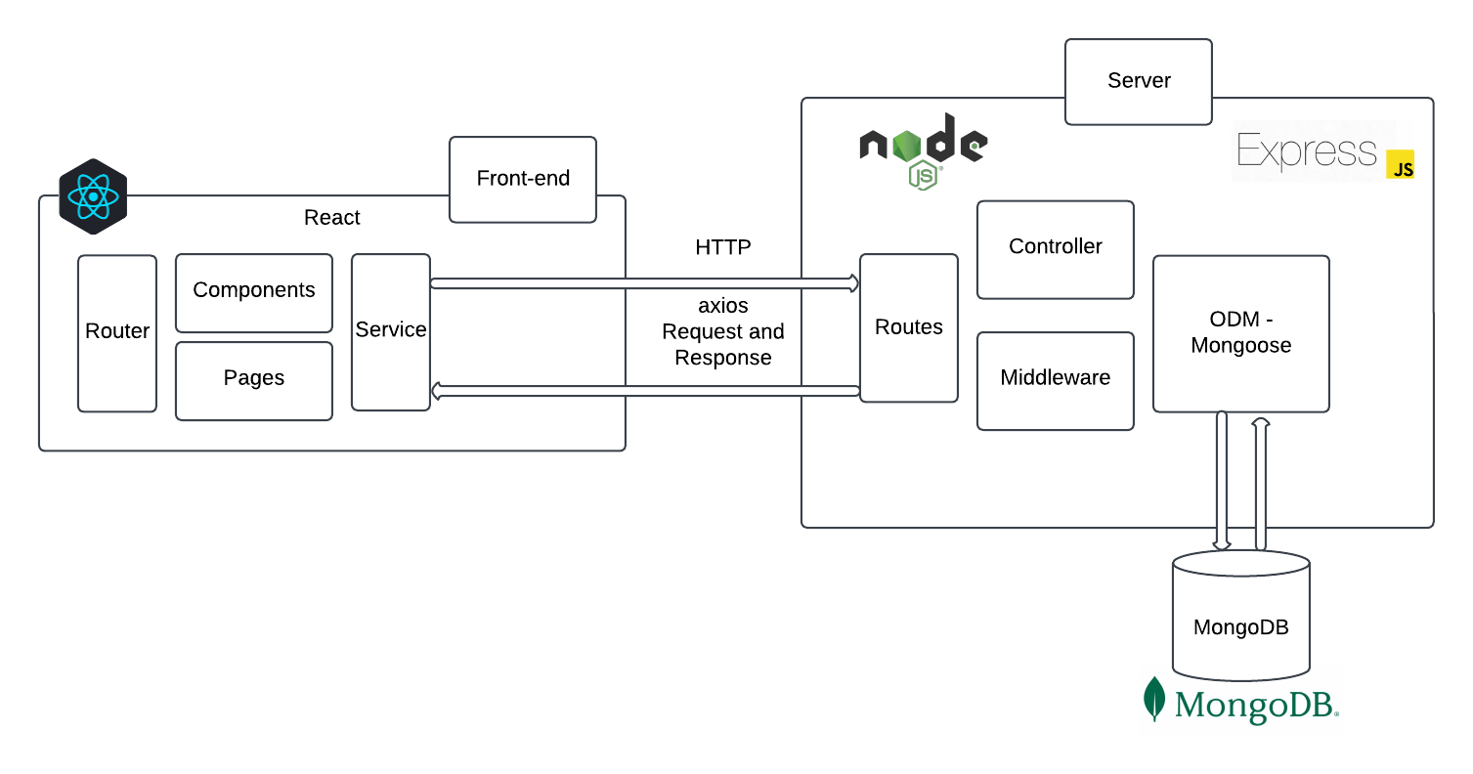

***FIGURE 1.ARCHITECTURE***

**FRONTEND:**

**Frontend Development with React.js**

The frontend of the application will be developed using React.js, aiming to provide a responsive, single-page application (SPA) experience. React’s component-based architecture allows for reusable components and efficient rendering. Below are the key components and functionalities of the application, as well as the state management, authentication, routing, and other details.

**Key Components:**

**Home Component:**

This component will serve as the landing page for users. It will display featured properties, which could be highlighted or curated listings. Additionally, it will offer search filters to allow users to quickly narrow down the property listings based on certain criteria such as price, location, size, etc.

**Features:**

Displaying featured properties (e.g., top picks or recently added listings).

Search bar with filtering options (e.g., price range, location, property type).

Promotional or news banners if needed.

Pagination or infinite scroll for property previews.

**Property Listing Component:**

This component will display a list of all available properties, offering users a detailed overview of each one. Users can apply additional filters like location, price, number of bedrooms, etc., to narrow down the search results.

**Features:**

A grid or list view of property cards with key information (name, price, location).

Filter options on the sidebar or as a dropdown menu for easy navigation.

Sorting options (e.g., by price, date, or popularity).

Pagination or infinite scroll for smoother browsing.

**Property Details Component:**

When a user clicks on a property from the listings, they will be directed to the Property Details Component, which will display all the information about a particular property in a comprehensive format.

**Features:**

Full property details such as price, location, number of rooms, amenities, etc.

Image gallery or video walkthrough of the property.

Contact form for inquiries.

Map view to show the property’s location.

Reviews or ratings from previous tenants (if applicable).

**User Profile Component:**

This component is dedicated to users who are registered and logged in. It will allow users to manage their personal information, track their saved properties, and list any properties they may have available for rent.

**Features:**

Edit personal information (name, email, contact details).

View and manage listed properties (add, update, delete).

View saved rentals and saved searches for quick access.

View history of viewed properties for reference.

Account settings (change password, notification preferences).

**Admin Dashboard Component:**

A restricted access dashboard designed for administrators to monitor and manage the activity within the app. It provides a consolidated view of user activity, property management, and content moderation.

**Features:**

User management (view, edit, or deactivate user accounts).

Property management (approve, reject, or remove properties).

Analytics (track activity such as property views, user registration, etc.).

Ability to manage reports from users about properties or user behavior.

Control over content (e.g., banners, promotional materials).

Notification management to send alerts or reminders to users.

**State Management:**

To handle the dynamic nature of the application, state management will be required for managing the data across the application (e.g., user information, property data, filter settings, etc.). There are two main options for managing state in React:

**React Context API:**

A built-in state management tool within React that allows global state to be shared across components. It's relatively simple and ideal for smaller to medium-sized applications.

**Use cases:**

Storing user authentication state.

Sharing filter settings across components.

Passing data down the component tree without prop-drilling.

**Redux:**

A more robust state management solution, especially for larger applications with complex state interactions. Redux can be used to centralize the state in a single store and provides tools for managing side effects, asynchronous actions, and API responses more effectively.

**Use cases:**

Handling user authentication flow and storing JWT tokens.

Managing the application-wide property listings state.

Storing UI-related state (like filters, loading states).

Both approaches are feasible, and the choice depends on the scale and complexity of the application. For a medium-sized app, React Context might suffice, but for larger or more complex applications, Redux could be the better choice.

**Authentication:**

The application will use JWT (JSON Web Tokens) for handling user authentication. Here’s how it will work:

**Login:**

When a user logs in, they’ll provide their credentials (username and password), and upon successful authentication, the server will return a JWT.

This JWT is stored either in localStorage or HTTP-only cookies for subsequent requests.

**Token Storage:**

LocalStorage is an easy way to persist tokens but can be vulnerable to cross-site scripting (XSS) attacks.

HTTP-only cookies are more secure, as they can’t be accessed by JavaScript, mitigating XSS risks but can be prone to cross-site request forgery (CSRF) if not implemented correctly.

**API Authorization:**

Every request to the backend (such as fetching user data or managing properties) will include the JWT in the request header (Authorization: Bearer <token>).

The backend will verify the token and ensure the user has appropriate permissions for the requested action.

**Token Expiry and Refresh:**

JWT tokens will have an expiry time. The application will need to handle token expiration and provide a refresh token to renew the JWT when needed.

**Routing:**

For navigation between different pages or components, React Router will be used. React Router is a powerful routing library that allows you to manage navigation and URLs in a single-page application without the need for full page reloads.

**BACKEND:**

***Node.js and express.js***

The backend will be built using Node.js and Express.js to handle HTTP requests, API routes, and business logic. Node.js provides an event-driven, non-blocking I/O model, ideal for handling high-concurrency applications, while Express.js simplifies route management, request handling, and middleware usage. Together, they will ensure the backend is scalable, fast, and efficient, providing a solid foundation for handling complex interactions like user authentication and property management.

***Restful api***

A RESTful API will be built to handle client-server communication with standard HTTP methods (GET, POST, PUT, and DELETE). The API will provide endpoints for key functionalities such as user authentication, property management, and notifications. The API will return data in JSON format and will be designed to be stateless, with error handling integrated for robust communication between the frontend and backend.

***User authentication***

User authentication will be handled using JWT (JSON Web Tokens), allowing users to sign up, log in, log out, and reset their passwords securely:

* ***Signup***: Users provide email, password, and other details, and upon validation, their credentials are saved in the database with hashed passwords.
* ***Login:*** Upon successful login, a JWT token is issued, which is stored in local Storage or HTTP-only cookies for future authentication.
* ***Logout***: JWT tokens are removed from storage, and the user is logged out.
* ***Password Reset***: A secure link is sent to the user's email to reset their password.

The backend ensures secure handling of sensitive data, including encrypted passwords and token-based authentication.

***Property management***

Property management will allow CRUD (Create, Read, Update, Delete) operations on property listings:

* ***Create Property***: Users can submit property details (e.g., price, location, photos) to create new listings.
* ***Read Property***: Users can view property listings or details with filtering options (location, price, type).
* ***Update Property***: Property owners can update their listings (price, description, etc.).
* ***Delete Property***: Property owners can delete their listings.

Images for properties will be uploaded to a cloud service like Amazon S3, with URLs stored in the database.

***Messaging system***

The Messaging System will have API routes for sending and receiving messages between users (tenants, landlords, and admins). Each message will be stored in a database and associated with relevant users and properties. Routes will include:

POST /messages: For sending messages between users.

GET /messages: For retrieving conversations or specific messages.

GET /messages/:id: For viewing individual message details.

This system will allow real-time communication between tenants and landlords for inquiries or negotiations.

***Admin operations***

Admin Operations will include routes for managing users, properties, and reports.

**Security and authorization**

Security and Authorization will be managed using JWT for role-based access control. Middleware will be implemented to protect routes based on user roles (e.g., admin, tenant, landlord):

* ***JWT Authentication Middleware:*** Ensures users are logged in before accessing sensitive data.
* ***Role-based Authorization Middleware:*** Checks user roles for accessing specific routes (e.g., only admins can access user management routes).

This ensures that only authorized users can access restricted resources and perform actions based on their role.

**File uploads**

A dedicated endpoint for image uploads will be set up to handle property photos. The backend will allow users (landlords) to upload images for properties.

The images will be stored securely in the cloud, and URLs will be stored in the database, linked to the relevant property listings.

***Database:***

The database uses MongoDB with a schema defined through Mongoose. Collections are created to manage Users, Products, Orders, and Cart items, ensuring data integrity and efficient querying.

**MongoDB:**

     Use MongoDB to store data related to users, properties, reviews, messages, and more.

**Database models:**

**1. User Model:** Stores user information such as name, email, password (hashed), role (tenant, landlord, admin), and profile details.

**2. Property Model:** Stores information about each property, including address, description, rent price, owner ID, images, and other details.

**3. Message Model:** Stores message threads between users.

**4. Booking or Viewing Requests Model:** Stores tenant requests for viewing or booking properties.

**5. Review Model:** Stores reviews submitted by tenants for properties and landlords.

**6. Indexes:** Ensure frequently searched fields, like location and price, are indexed for faster queries

**IV. SETUP INSTRUCTIONS**

***BACKEND PREREQUISITES:***

1. **Prerequisites:**

* Node.js and npm: Download and install from [Node.js](https://nodejs.org).
* MongoDB: You can set up a local MongoDB instance or use MongoDB Atlas for a cloud database.
* Git: For version control (optional but recommended).

**2 .Installation:**

**Navigate to the backend directory:** cd backend

* **Install the backend dependencies:  
  bash** npm install express mongoose dotenv jsonwebtoken bcryptjs cors
* **.Install development dependencies for easier development:  
           bash** npm install --save-dev nodemon

**3. Create a .env file for environment variables** in the backend directory and add the      following variables (with appropriate values for your setup):

makefileMONGO_URI=your_mongodb_connection_string

JWT_SECRET=your_jwt_secret

PORT=3000

**4. Start the backend server in development mode:** npm start

**5.This will run the backend on** [**http://localhost:3000**](http://localhost:3000) **.**

***FRONTEND PREREQUISITES:***

* **Install the frontend dependencies:**npm install react react-dom react-router-dom axios
* **Start the React application:**npm start

This will start the frontend server on <http://localhost:3000>.

* **Install Frontend Dependencies**

Navigate to the client directory:cd frontend

**V FOLDER STRUCTURE:**

**Client:**

frontend/

│

├── public/ # Static assets (e.g., index.html, images)

├── src/ # React components, state management, and hooks

│ ├── components/ # Reusable UI components

│ ├── pages/ # Individual pages (e.g., Home, Login, Register)

│ ├── services/ # API calls to backend

│ ├── modules/ # Organized feature-specific components

│ │ ├── admin/ # Admin-related components (e.g., AdminHome, AllUsers)

│ │ ├── common/ # Common components (e.g., Login, Register)

│ │ ├── user/ # User-related components

│ │ │ ├── Owner/ # Owner-specific components (e.g., AddProperty)

│ │ │ └── Renter/ # Renter-specific components (e.g., RenterHome)

│ ├── App.css # Global styles

│ ├── App.js # Main app component

│ └── index.js # Entry point for React app

├── package.json # Frontend dependencies and scripts

└── README.md # Project documentation

│ ├── App.js # Main app component

│ └── index.js # Entry point for React app

└── package.json # Frontend dependencies and scripts

**Server:**

Backend/

│

├── config/ # Configuration files (e.g., DB connection)

│ └── connect.js # Database connection setup

├── controllers/ # Business logic for each route

│ ├── adminController.js

│ ├── ownerController.js

│ └── userController.js

├── middlewares/ # Authentication, error handling, etc.

│ └── authMiddleware.js

├── routes/ # API routes (e.g., /auth, /users, /properties)

│ ├── adminRoutes.js

│ ├── ownerRoutes.js

│ └── userRoutes.js

├── schemas/ # Mongoose models

│ ├── bookingModel.js

│ ├── propertyModel.js

│ └── userModel.js

├── uploads/ # Folder for file uploads (e.g., images)

├── server.js # Main entry point for the server

├── .env # Environment variables

├── package.json # Backend dependencies and scripts

└── README.md # Server documentation

**VI RUNNING THE APPLICATION**

**Prerequisites**

Install Node.js (latest LTS version recommended).

Install MongoDB and ensure it's running locally or use a cloud-based MongoDB service like MongoDB Atlas.

Ensure you have npm or yarn installed (comes with Node.js).

Clone the repository to your local machine:

git clone https://github.com/venkatesh1220/DreamHome_Naan_Mudhalvan_MERN.git

cd DreamHome_Naan_Mudhalvan_MERN

Backend Setup

Navigate to the backend directory:

cd backend

**Install dependencies:**

npm install

Create a .env file in the backend folder and add the following environment variables:

PORT=5000

MONGO_URI=<your_mongodb_connection_string>

JWT_SECRET=<your_jwt_secret>

Replace <your_mongodb_connection_string> with your MongoDB connection string (e.g., from MongoDB Atlas or your local MongoDB instance).

Replace <your_jwt_secret> with a strong secret key for JWT token generation.

Start the backend server:

npm start

**Frontend Setup:**

Navigate to the frontend directory:

cd ../frontend

Install dependencies:

npm install

Start the React development server:

npm start

The frontend server should start at http://localhost:3000.

Access the Application

Open http://localhost:3000 in your browser.

Directory Overview

backend: Contains server-side code, API endpoints, and MongoDB schema models.

frontend: Contains React-based client-side code for the user interface.

**VII API DOCUMENTATION**

**Authentication:**

1. Login:

URL: /auth/login

Method: POST

Description: Authenticates a user and returns a JWT token.

Request Body:

{

"email": "user@example.com",

"password": "password123"

}

**Response:**

Success (HTTP 200):

{

"message": "Login successful",

"token": "your_jwt_token"

}

Failure (HTTP 401):

{

"message": "Invalid email or password"

}

2. **Register**

URL: /auth/register

Method: POST

Description: Registers a new user.

Request Body:

{

"name": "John Doe",

"email": "user@example.com",

"password": "password123",

"role": "owner" // or "renter"

}

**Response:**

Success (HTTP 201):

{

"message": "User registered successfully"

}

Failure (HTTP 400):

{

"message": "Email already exists"

}

**Properties**

3.**Add Property**

URL: /properties/add

Method: POST

Description: Allows an owner to add a new property.

Headers:

Authorization: Bearer <your_token>

Request Body:

{

"title": "3 BHK Apartment",

"description": "A beautiful apartment in the city center.",

"price": 25000,

"address": "123 Street Name, City",

"image": "base64_image_data"

}

**Response:**

Success (HTTP 201):

{

"message": "Property added successfully"

}

Failure (HTTP 400):

{

"message": "Failed to add property"

}

4. **Get All Properties**

URL: /properties

Method: GET

Description: Fetches all properties for renters to view.

Response:

Success (HTTP 200):

[

{

"id": "123",

"title": "3 BHK Apartment",

"description": "A beautiful apartment in the city center.",

"price": 25000,

"address": "123 Street Name, City",

"image": "image_url"

}

]

5**. Delete Property**

URL: /properties/:id

Method: DELETE

Description: Allows an owner to delete a property.

Headers:

Authorization: Bearer <your_token>

URL Params:

id: Property ID

Response:

Success (HTTP 200):

{

"message": "Property deleted successfully"

}

Failure (HTTP 404):

{

"message": "Property not found"

}

**Bookings**

6. **Create Booking**

URL: /bookings/create

Method: POST

Description: Allows a renter to book a property.

**Headers:**

Authorization: Bearer <your_token>

Request Body:

{

"propertyId": "123",

"startDate": "2024-11-25",

"endDate": "2024-11-30"

}

**Response:**

Success (HTTP 201):

{

"message": "Booking created successfully"

}

Failure (HTTP 400):

{

"message": "Failed to create booking"

}

7. **Get All Bookings**

URL: /bookings

Method: GET

Description: Fetches all bookings for the logged-in user.

Headers:

Authorization: Bearer <your_token>

**Response:**

Success (HTTP 200):

[

{

"id": "123",

"propertyId": "123",

"startDate": "2024-11-25",

"endDate": "2024-11-30",

"status": "confirmed"

}

]

**Admin Operations**

8. **Get All Users**

URL: /admin/users

Method: GET

**Description:** Fetches all users (admin only).

**Headers:**

Authorization: Bearer <your_token>

**Response:**

Success (HTTP 200):

[

{

"id": "123",

"name": "John Doe",

"email": "user@example.com",

"role": "owner"

}

]

9. **Delete User**

URL: /admin/users/:id

Method: DELETE

Description: Allows the admin to delete a user.

**Headers:**

Authorization: Bearer <your_token>

URL Params:

id: User ID

**Response:**

Success (HTTP 200):

{

"message": "User deleted successfully"

}

**Error Handling**

400 Bad Request: When invalid data is provided.

401 Unauthorized: When token is missing or invalid.

404 Not Found: When a resource does not exist.

500 Internal Server Error: When something unexpected occurs on the server.

**VIII AUTHENTICATION**

Authentication is the process of verifying the identity of a user or system to ensure that the individual or entity is who they claim to be. It is a critical aspect of web application security, ensuring that only authorized users can access certain resources or functionalities.

***Types of Authentication Methods***

1. **Basic Authentication**:

**Description**: Involves sending a username and password in the HTTP header. This method is simple but not secure on its own, as credentials are often transmitted in plaintext unless the connection is secured (e.g., over HTTPS).

**Use Cases**: Often used for quick, low-level access where security isn’t a major concern or in legacy systems.

**2. Form-Based Authentication**:

**Description**: Involves a login form where users enter their credentials (username and password), which are then validated by the server. This method can be enhanced with additional features like session management (cookies) and encryption.

**Use Cases**: Commonly used in web applications, especially those that require user registration and login.

**3. Token-Based Authentication (e.g., JWT)**:

**Description**: The server generates a token (usually a JSON Web Token, JWT) after the user logs in. The token is then sent with each request, typically in the HTTP Authorization header. This method is stateless and doesn’t require the server to store session data.

**Use Cases**: Ideal for RESTful APIs and single-page applications (SPAs), especially for handling distributed, scalable systems.

**4. Session-Based Authentication**:

**Description**: After a successful login, the server creates a session and stores session information, typically in a cookie. The session is used to track user interactions and maintain login state without requiring the user to re-enter credentials.

**Use Cases**: Most traditional web applications use session-based authentication for maintaining user sessions.

1. **API Key Authentication**:

**Description**: Involves sending an API key, which is a unique identifier, in requests to authenticate API calls. The server verifies the key and grants access to the requested resources.

**Use Cases**: Common in APIs and microservices, especially for public or internal APIs.

**Authentication flow**

**User Login:** The user submits credentials (username and password) via a login form or API endpoint.

**Server Validation**: The server checks the credentials against a database. If the credentials are valid, the server generates a session or token.

**Session/Token Creation**: For session-based authentication, the server creates a session and stores it in memory or a database. For token-based authentication (like JWT), a token is generated and sent to the client.

**Accessing Resources**: The client sends the session ID or authentication token with each request to access protected resources.

**Logout/Session Expiry**: On logout, the session is destroyed, or the token expires, requiring the user to authenticate again.

**Authentication security practices**

* **Use HTTPS**: Always use HTTPS to encrypt credentials during transmission, ensuring that sensitive data like usernames and passwords aren’t exposed during transit.
* **Password Hashing**: Store passwords securely by hashing them (using algorithms like bcrypt or Argon2) instead of storing them in plaintext.
* **Avoid Storing Plaintext Tokens**: If using tokens like JWT, ensure they are signed and optionally encrypted to prevent tampering.
* **Limit Login Attempts**: Implement mechanisms to prevent brute-force attacks by limiting the number of login attempts per user.
* **Session Timeout**: Implement session expiration to reduce the risk of unauthorized access in case a session is hijacked.
* **Secure Cookie Attributes**: Set cookies with secure attributes such as HttpOnly, Secure, and SameSite to prevent cross-site scripting (XSS) and cross-site request forgery (CSRF) attacks.

**IX USER INTERFACE**

The User Interface (UI) plays a crucial role in allowing users to interact with a web application, particularly when it comes to logging in and authenticating their identity. In the context of a House Rent Application using the MERN stack, the login process and integration with a MongoDB database ensure that user credentials are stored and securely managed.

***User Login Process***

* **Login UI**: The login page allows users to input their credentials (username and password). This page typically includes a form with fields for the user’s username/email and password, along with a button to submit the form and attempt to log in. Additional options, such as a forgot password link or a signup link for new users, might also be available.
* **Submitting Credentials**: Once the user enters their information, the form data is sent to the backend for verification. The backend checks the credentials against the stored user data in the database (MongoDB).

**BACKEND AUTHENTICATION PROCESS**

***MongoDB Database****:*

* MongoDB stores user data, including usernames, email addresses, and hashed passwords. The database is structured as a collection of documents, each representing a user’s profile.
* When a user submits their login credentials, the backend queries the MongoDB database to find the document that matches the entered username or email.

***Password Verification:***

The backend compares the entered password with the hashed version stored in MongoDB. This ensures that passwords are not stored in plaintext, offering better security for the user’s sensitive data.

***Session or Token Creation****:*

Once the credentials are validated, the server generates a session or an authentication token (e.g., JWT - JSON Web Token) that is sent back to the frontend. This token is used to authenticate future requests from the user without needing to re-enter credentials.

**STORING DATA IN MONGODB**

**User Data Storage**:

* After user registration (sign-up), the credentials (username, email, password) are stored in MongoDB. The password is hashed before it is saved, ensuring that sensitive data is protected.
* MongoDB provides flexibility in storing various types of data, including user profiles, preferences, and other personalized settings.

**Data Retrieval**:

* Once the user is logged in, their session or token allows them to access personalized resources, such as viewing rental listings, updating their profile, or managing other data specific to the application.
* The backend queries MongoDB to retrieve the necessary data for the authenticated user.

**SESSION MANAGEMENT AND ACCESS CONTROL**

**Session Handling**:

* After successful login, a session is created on the server, or a token is issued. This token is stored on the client side (usually in local storage or cookies) and is included in subsequent requests to authenticate the user.
* Sessions or tokens ensure that users remain logged in across different pages or actions within the application.

**Access Control**:

The backend checks the session or token with each request to confirm that the user is authorized to access certain resources. For example, a user can view their rental listings or update their profile, but they cannot access another user's data unless they have the appropriate permissions.

**User Interface Feedback**

**Successful Login**:

Upon successful authentication, the UI typically redirects the user to the main dashboard or home page. The user can now interact with the application, such as browsing rental listings, submitting inquiries, or updating personal information.

**Error Handling**:

If the login attempt fails (e.g., incorrect credentials), the UI will show an error message, prompting the user to check their username and password or try resetting their password.

**SECURITY CONSIDERATIONS**

**Data Protection**:

Sensitive information such as passwords is never stored in plain text. Instead, they are securely hashed before being saved in MongoDB. This helps prevent unauthorized access if the database is compromised.

**Token Expiry**:

Tokens used for authentication often have an expiration time. This helps prevent unauthorized access if a session is left open for too long, enhancing security.

**X. TESTING**

When developing a rental home application using the MERN stack (MongoDB, Express.js, React.js, Node.js), it's crucial to implement various testing strategies to ensure that the application works as expected and meets the requirements. Each part of the MERN stack has its own testing needs, and there are different tools and methodologies you can use for each layer of the stack. Below is a detailed breakdown of the testing strategies and the tools you can use for a rental home application.

**1. Unit Testing**

**Objective:**

Ensure that individual units or components of your application (such as functions, classes, or React components) work as expected in isolation.

**Tools:**

**Frontend (React.js)**:

**Jest**: A popular testing framework for JavaScript that works well with React. It provides utilities to mock functions and check if a component behaves as expected.

**React Testing Library**: This helps you test React components by rendering them and interacting with them as a user would (e.g., clicking buttons, entering input).

**Enzyme** (Alternative to React Testing Library): Another testing utility for React that allows you to shallow render components, simulate events, and make assertions on component behaviour

**Backend (Node.js/Express.js):**

**Jest** or **Mocha + Chai**: These tools allow you to test API endpoints, business logic, and database interaction in isolation. You can mock dependencies like database calls to test your functions without interacting with the actual database.

**2. Integration Testing**

**Objective:**

Ensure that multiple components or services work together as expected. This includes interactions between the frontend and backend, as well as between backend services like database operations.

**Tools:**

**Supertest**: A popular library for testing HTTP endpoints. It can be used to test how well the frontend interacts with the backend.

Jest or Mocha + Chai for integration testing.

**MongoDB Memory Server**: For testing the backend in isolation without affecting the real database. It creates an in-memory MongoDB instance to run tests.

**3. End-to-End (E2E) Testing**

**Objective:**

Simulate real-world user scenarios and test the entire application stack from start to finish. E2E tests verify the user experience across all layers of the app.

**Tools:**

**Cypress**: A popular end-to-end testing framework that allows you to interact with your app in a real browser and simulate user interactions. It supports features like automatic waiting, debugging, and screenshot capturing.

**Selenium**: An alternative to Cypress, useful for testing in multiple browsers, but more complex to set up.

**Playwright**: Another end-to-end testing framework similar to Cypress, but it allows for testing across multiple browsers (Chrome, Firefox, WebKit).

**4. Security Testing**

**Objective:**

Identify vulnerabilities and ensure that the application handles sensitive data securely.

**Tools:**

**OWASP ZAP** (Zed Attack Proxy): A tool for finding security vulnerabilities in web applications. It can be used for penetration testing and scanning for common vulnerabilities such as XSS, SQL injection, and CSRF.

**Burp Suite**: Another tool for security testing and vulnerability scanning.

**Jest** (for testing API authentication): Ensure that unauthorized users cannot access protected routes.

**Summary of Testing Strategies and Tools for MERN Stack:**

**1.Unit Testing**:

**Frontend**: Jest, React Testing Library, Enzyme

**Backend**: Jest, Mocha + Chai, Supertest

**2.Integration Testing**:

Supertest, MongoDB Memory Server, Jest

**3.End-to-End (E2E) Testing**:

Cypress, Selenium, Playwright

**4.Security Testing**:

OWASP ZAP, Burp Suite, Jest for authentication

**XI. SCREENSHOTS & DEMO**

**HOME PAGE :**

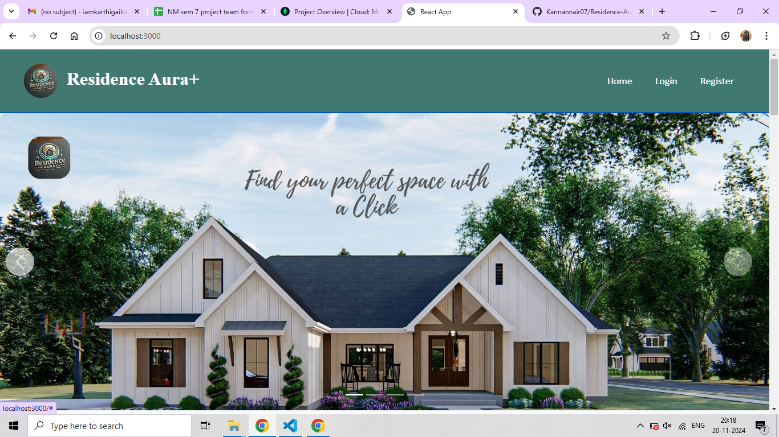

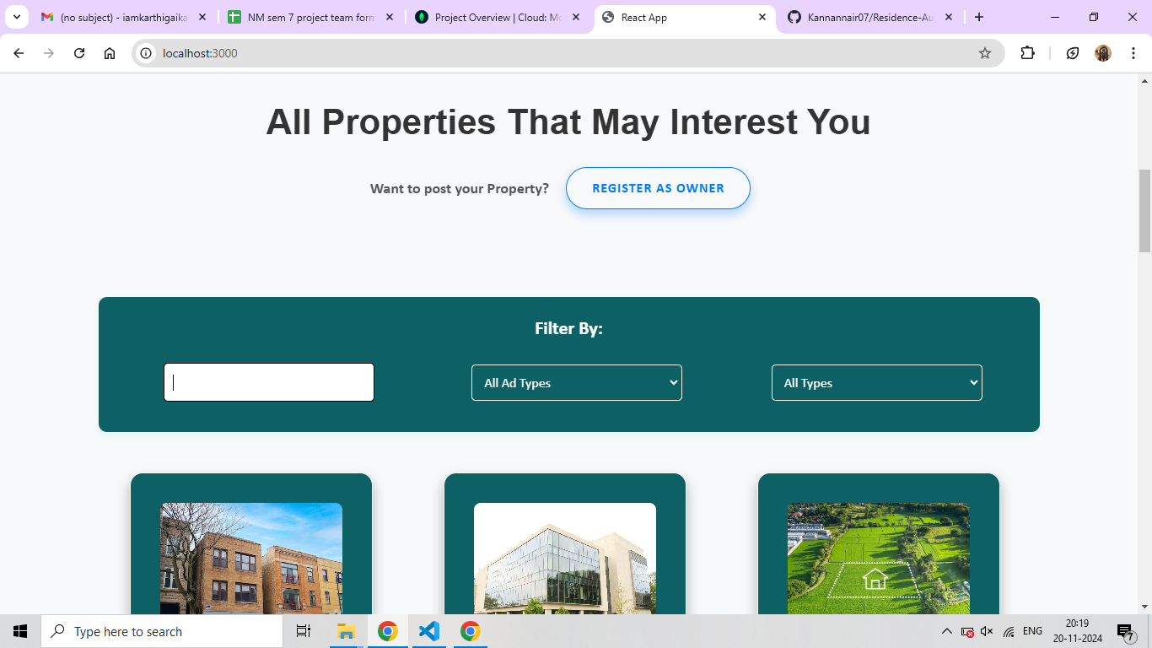

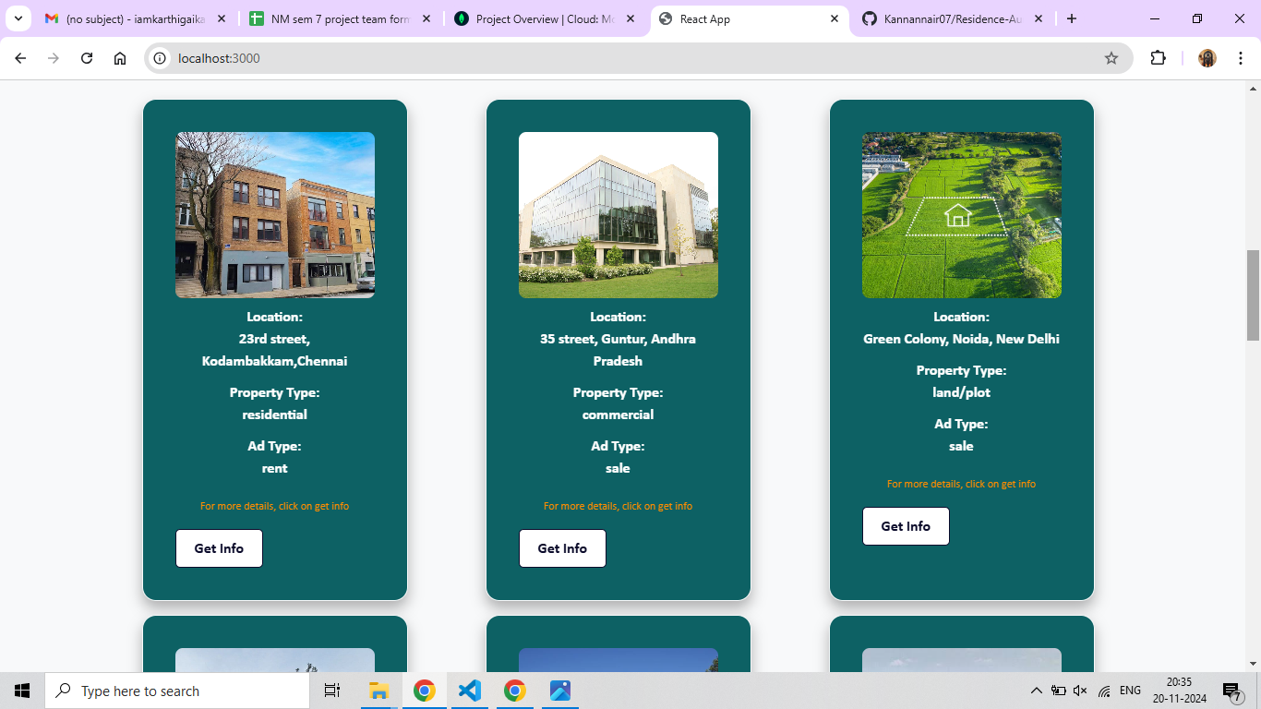

**LOGIN & REGISTER PAGE:**

**REGISTER:**

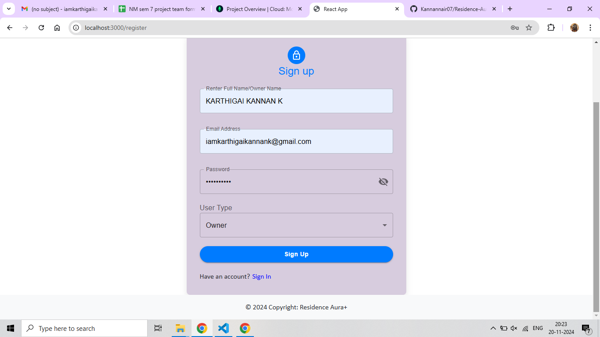

**LOGIN:**

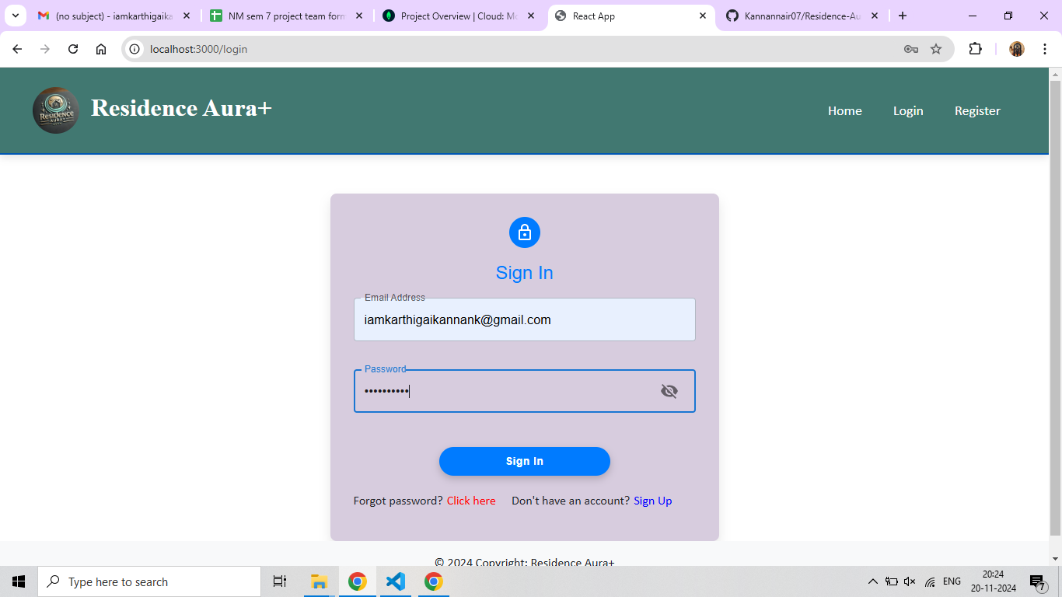

**FORGOT PASSWORD:**

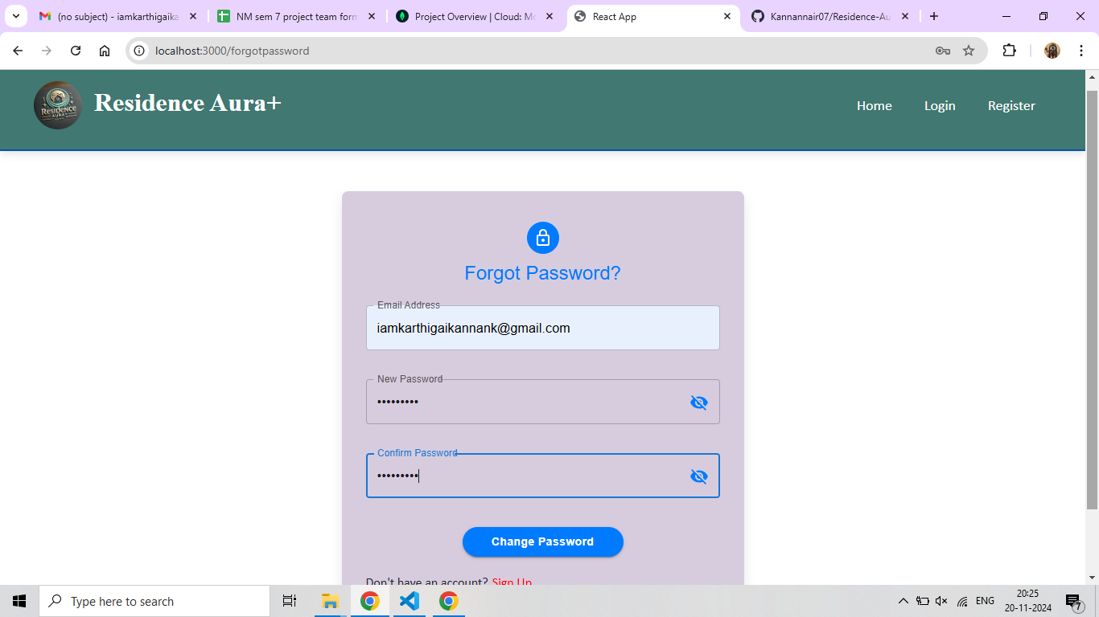

**ADMIN PANEL:**

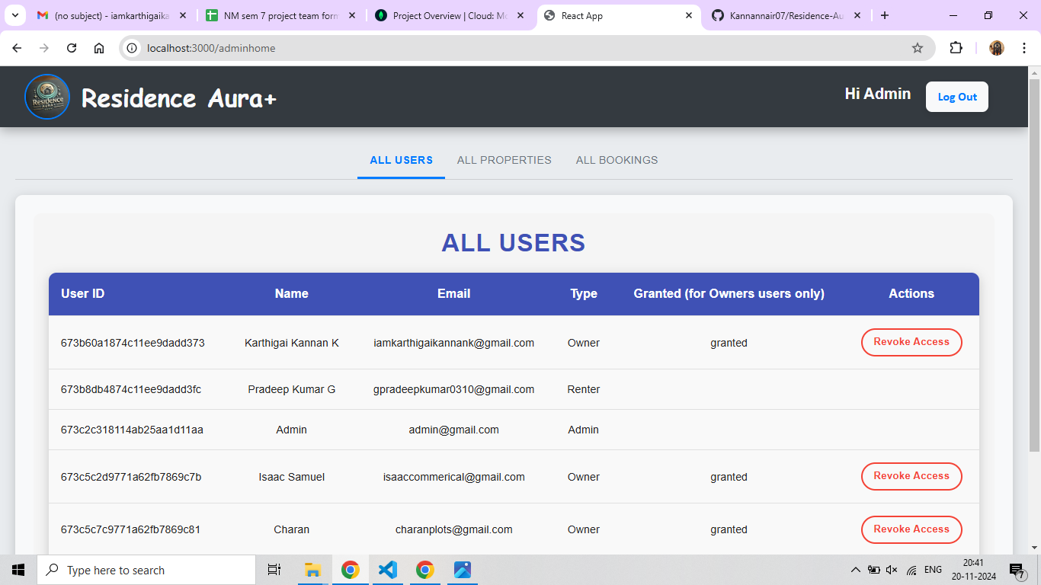

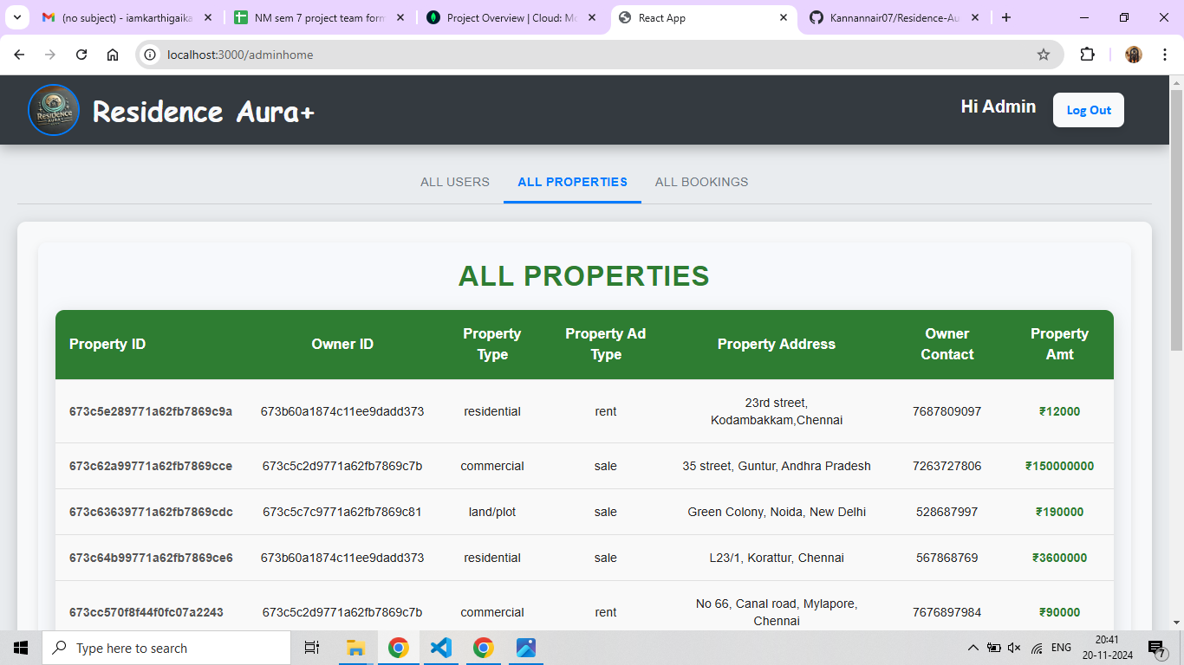

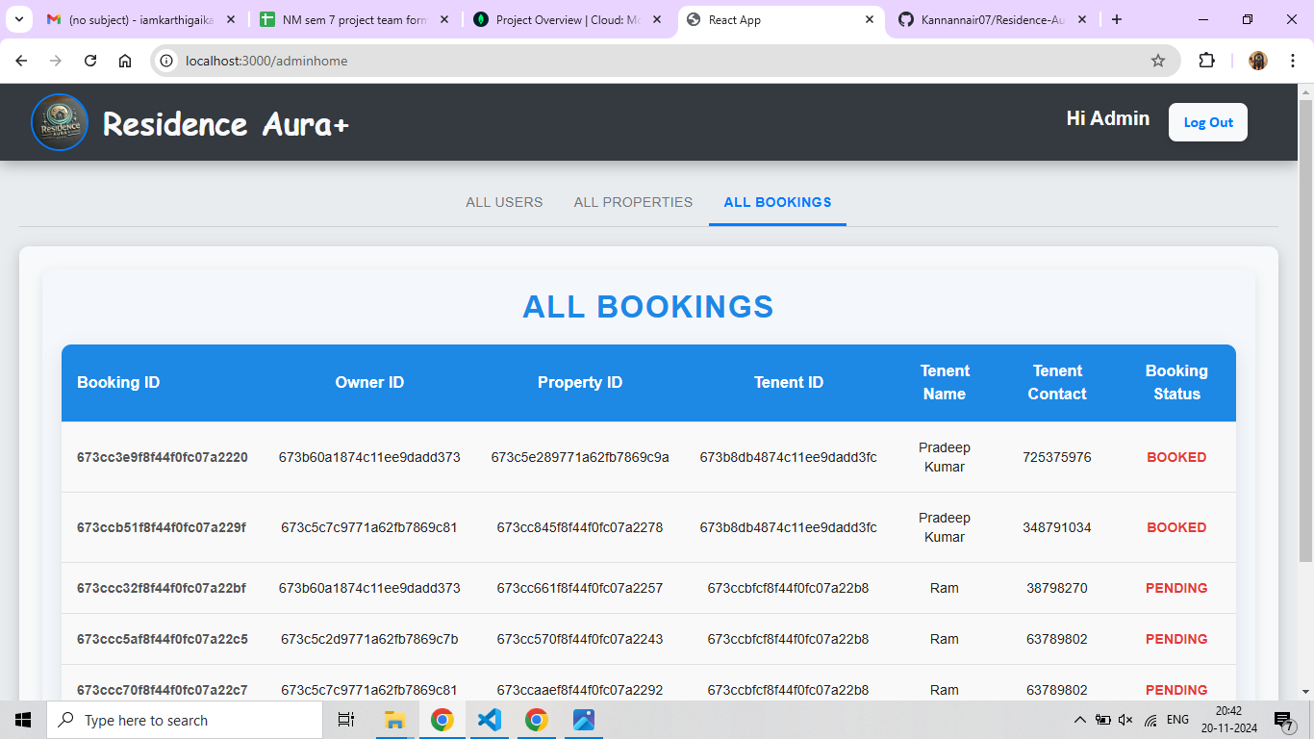

**OWNER PANEL:**

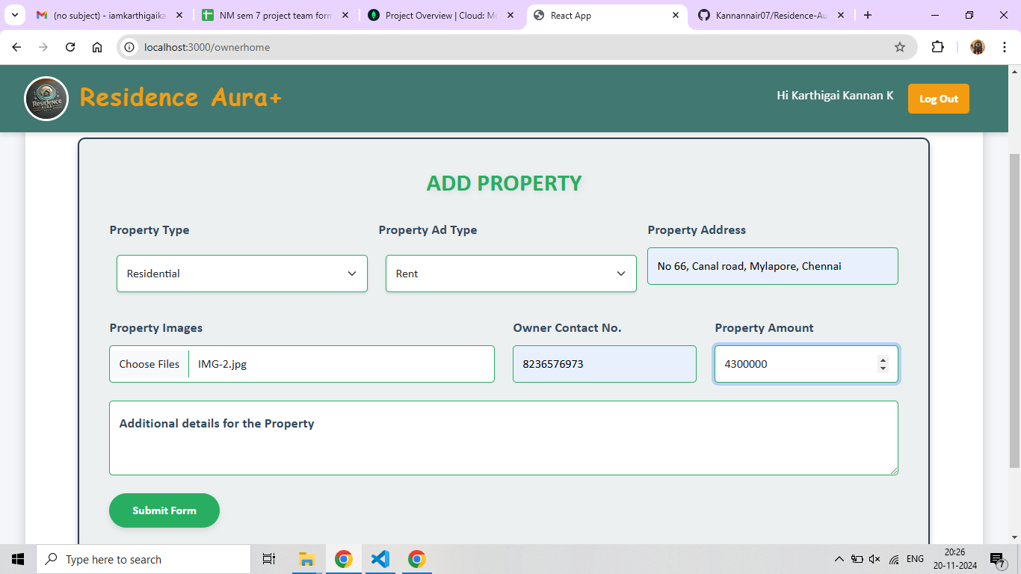

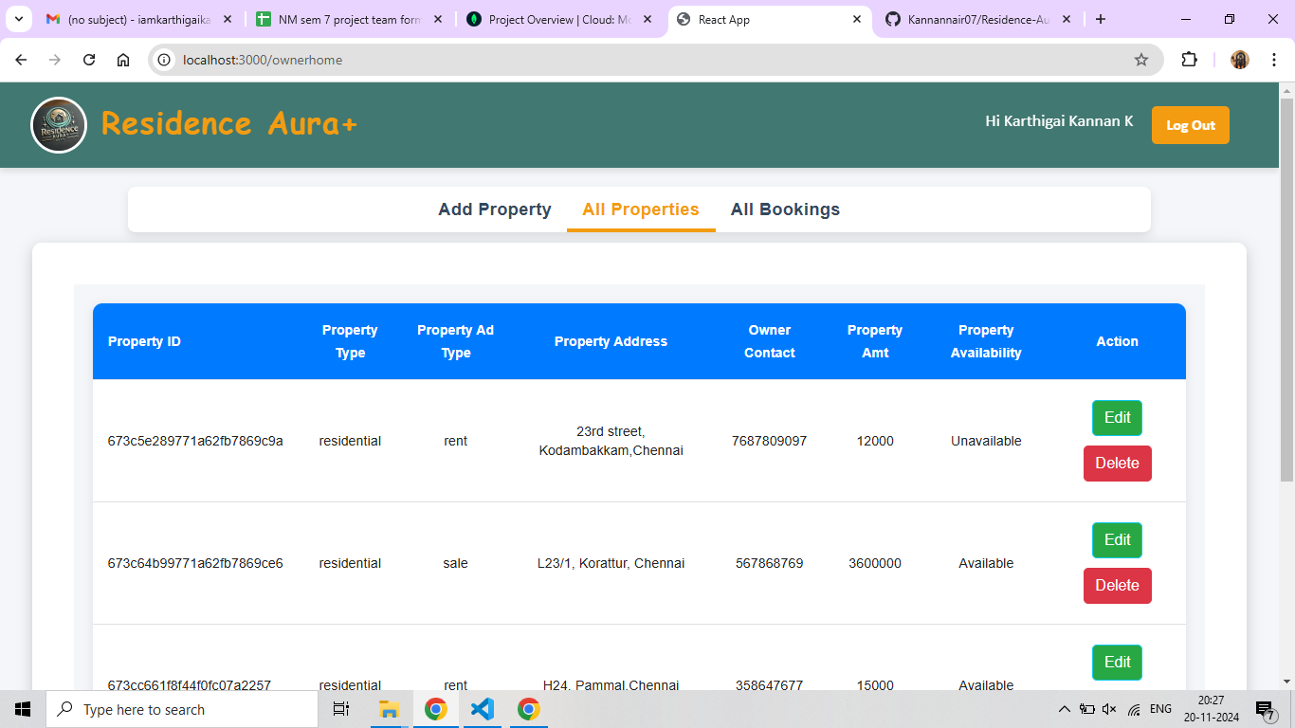

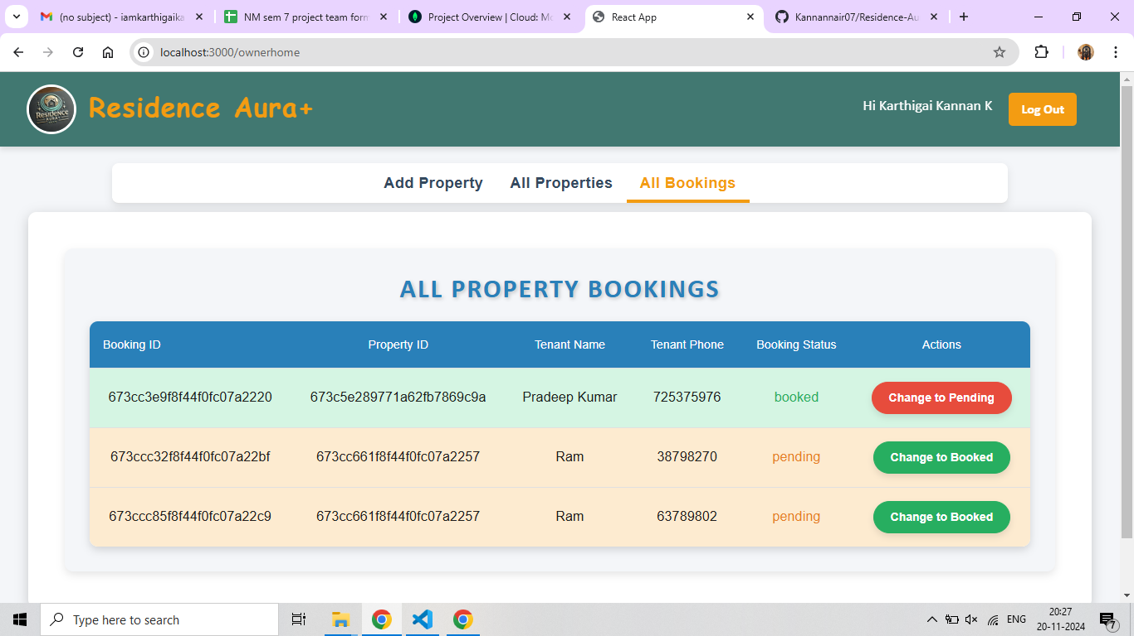

**TENANT PANEL:**

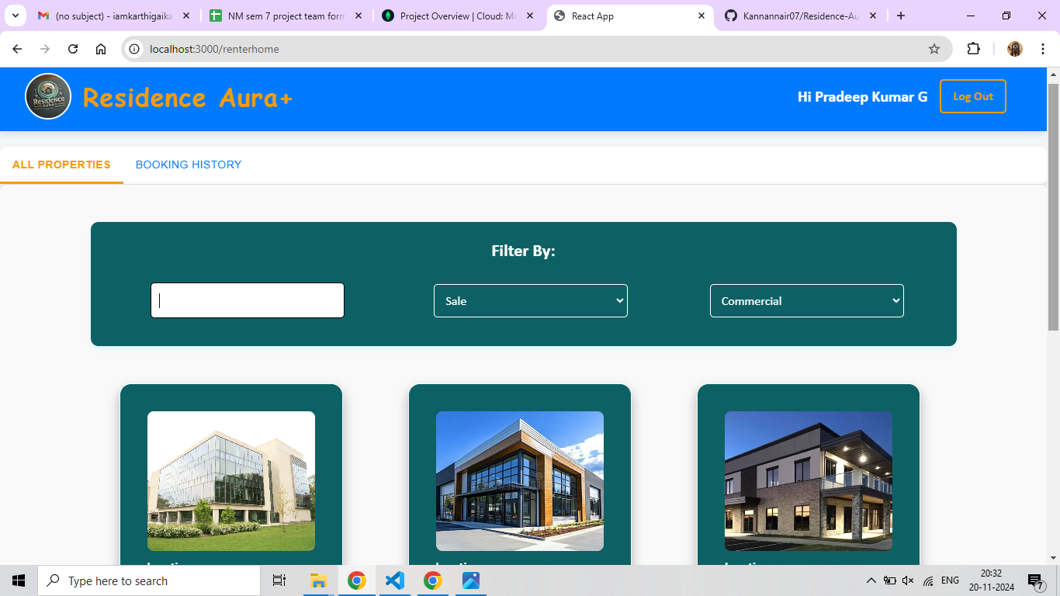

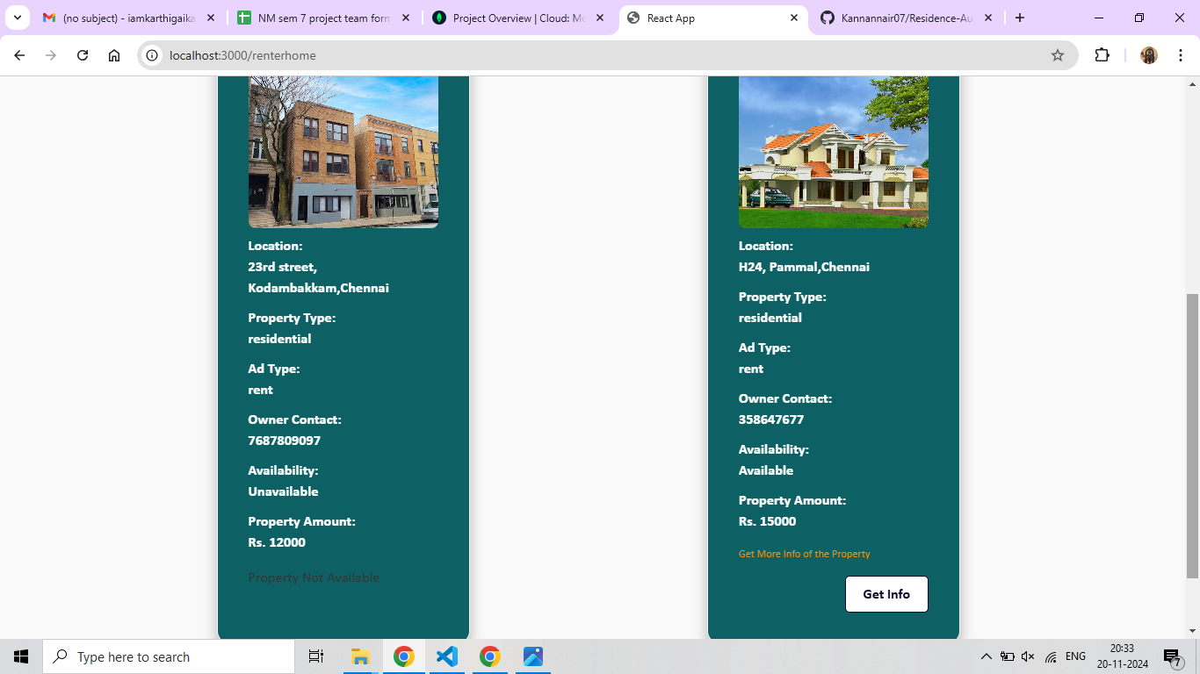

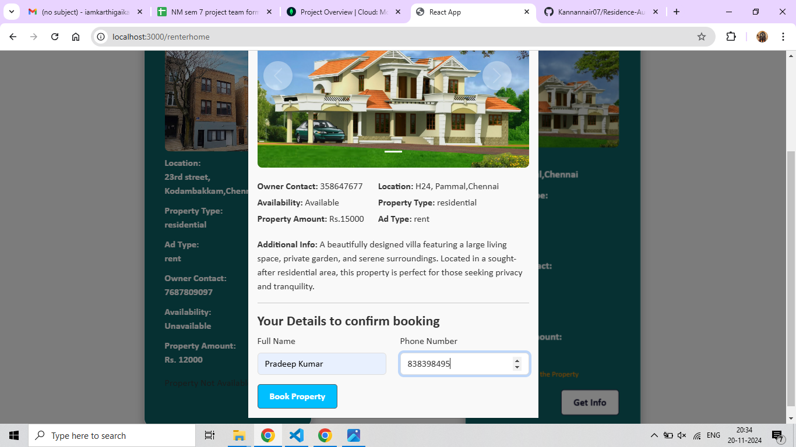

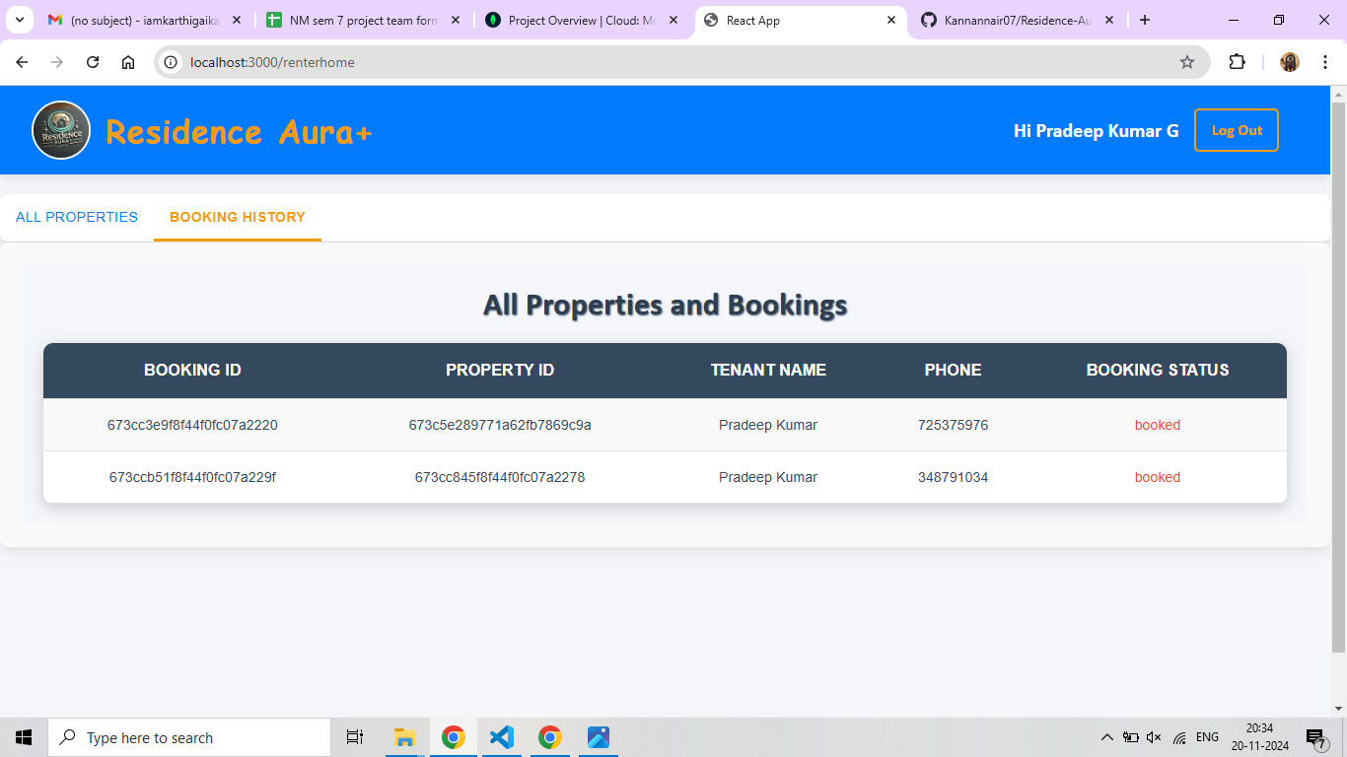

**DEMO VIDEO LINK:**   [**RESIDENCE AURA+**](https://drive.google.com/file/d/1_Y4YkLe64HvGVyidRPipDf6SNjOZR72P/view)

**XII. FUTURE ENHANCEMENTS**

**Browser Compatibility:**

Different browsers may interpret web elements slightly differently, leading to inconsistencies. Tests may pass on one browser but fail on another, requiring extra handling for cross-browser compatibility.

**Dynamic Content Handling:**

Selenium struggles with dynamic or JavaScript-heavy websites. Elements may not be immediately available or intractable, leading to errors like ElementNotVisibleException or ElementNotFoundException. Proper waits and handling of AJAX requests are necessary.

**Flaky Tests:**

Tests might intermittently pass or fail due to timing issues, especially in asynchronous environments. This can be caused by race conditions or slow network responses. Proper synchronization using WebDriverWait can mitigate this.

**WebDriver Crashes:**

Occasionally, WebDriver instances may crash or fail to initiate, often due to mismatches between browser versions and the corresponding WebDriver (e.g., ChromeDriver and Chrome).

**Slow Execution:**

Selenium's real-browser interactions make it slower compared to headless testing tools or mocking frameworks. This can be an issue when running large test suites or when tests need to run quickly in CI environments.

**Limited Mobile Testing Support:**

Although Appium extends Selenium's capabilities to mobile testing, setting up and executing mobile automation tests can be complex and less stable than web automation.

**XIII. CONCLUSION**

In conclusion, the House rent application offers a comprehensive, scalable, and user-friendly platform for managing house rentals, built using the MERN stack (MongoDB, Express.js, React, and Node.js). The platform caters to tenants, landlords, and admins, providing essential features such as property listings, advanced search and filtering, real-time messaging, and an intuitive admin panel. Tenants can easily search for and inquire about rental properties, while landlords can list, manage, and update their properties with ease. The inclusion of a secure authentication system, responsive design, and user-friendly interface ensures a smooth experience across devices.

The use of MongoDB as a NoSQL database, along with Express and Node.js for the backend, ensures scalability and flexibility, enabling the application to grow with added features like payment integration or machine learning-based recommendations. Additionally, the platform is designed with security in mind, implementing JWT-based authentication and robust data validation to protect user information. The admin panel enhances control, offering powerful tools for content moderation, analytics, and user management, ensuring smooth operations.

**GITHUB LINK:** [**HOUSE RENT APP**](https://github.com/Kannannair07/Residence-Aura_Naan-Mudhalvan_Project)